PATENT QUOTATION
Dated: 15/05/2025
Addressed to: Mr. Neeraj
I-HUB FOR ROBOTICS AND AUTONOMOUS
SYSTEMS INNOVATION FOUNDATION
Office Address: GROUND FLOOR, SID
ENTREPRENEURSHIP BUILDING
INDIAN INSTITUTE OF SCIENCE, BANGALORE -
560012.
GST No: 29AAFC18082AIZJ
Quotation Prepared by: Adv. Pranav Bhat
Contact Details: 9035685434
Email: an.astraea@gmail.com / pranavbhat334@gmail.com
Sl. No. | Particulars | Cost (Govt Fee + Prof Fee + Misc.)  For Individual/Startup/Small Entity/Educational  Institution
1. | Patent searching with oral opinion, Direct complete specification drafting, filing and request for early publication and Examination | 8,100+33,400+650 = 42,150/-
2. | Response to Examination | 0+25000+0 = 25,000/-
3. | Attending hearing and filing written submission | 0+33,000+0 = 33,000/-
 | TOTAL | Rs. 1,00,150/-
Notes:
- 50% of the quotation is payable upfront, with the remaining balance due at a later stage, to be mutually agreed upon
- An 18% GST will be applied to the professional fees.
- In case a similar quotation is required again for any other service, kindly reach out to us, and we will be happy to assist you.
- Any additional reimbursements, if applicable, will be informed to you priorly for your approval before proceeding.
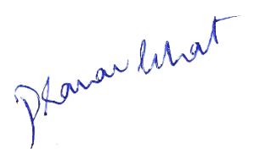

Should you have any questions or require further clarification, please feel free to contact us at the provided email or phone number. Thank you for considering our services. We look forward to assisting you with your intellectual property needs.

Best Regards,
Adv. Pranav Bhat, Chief IP Strategist
Lextria Research

